Customer Shopping Behavior Analysis

1. Project Overview

This project analyzes customer shopping behavior using transactional data from 3,900 purchases across various product categories. The goal is to uncover insights into spending patterns, customer segments, product preferences, and subscription behavior to guide strategic business decisions.

2. Dataset Summary

-Rows: 3,900
Columns: 18
- Key Features:
Customer demographics (Age, Gender, Location, Subscription Status)
- Purchase details (Item Purchased, Category, Purchase Amount, Season, Size, Color)
-Shopping behavior (Discount Applied, Promo Code Used, Previous Purchases, Frequency of Purchases, Review Rating. Shipping Type)
-Missing Data: 37 values in Review Rating column

3. Exploratory Data Analysis using Python

We began with data preparation and cleaning in Python:
-Data loading:imported the dataset using Pandas
-Initial Exploration:used file.info() to cheack structure and .describe() for summary statistics.
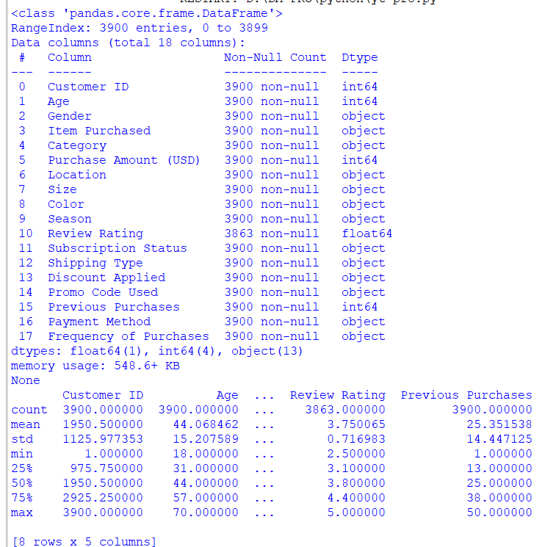

-Using Python visualization
-for visual:using matplotlib on import matplotlib.pyplot as plt
By bar chart
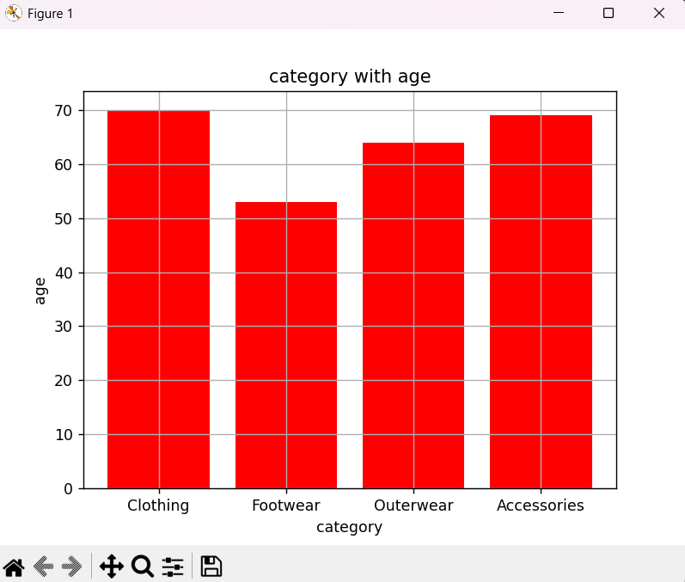

4.Data Analysis using SQl(
We performed structured analysis in PostgreSQL to answer key business questions:

- Revenue by Gender-Compared total revenue generated by male vs. female customers
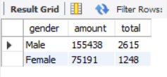
2.High-Spending Discount Users-Identified customers who used discounts but still spent above the average purchase amount
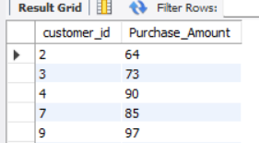

And more like this…..

5.Dashboard in Power BI

-finally ,we built an interactive dashboard in power BI to present insights visually.